## # 📘 Phase 5 – Part 5.2: Emergence of Gravity Wells via Temporal Feedback in ψ(x)

This part will:  
• Evolve ψ(x) over discrete time steps using the feedback loop:

$$ψ_{n+1}(x)=ψ_{n}(x)+β Curvature(x)$$

Plaintext: ψₙ₊₁(x) = ψₙ(x) + β * Curvature(x)

• Update gravity each step:

$${Gravity}_{n+1}(x)=Curvature(x)×ψ_{n+1}(x)$$

Plaintext: Gravityₙ₊₁(x) = Curvature * ψₙ₊₁(x)

* Show how gravity wells deepen as ψ reinforces the curvature structure
* Lay the groundwork for introducing tidal forces ($∂Gravity/∂x$) in Part 5.3

We’ll treat ψ as a growing trench, shaped by underlying curvature (spacetime depth). The deeper the ψ gets, the stronger the gravity it generates.  
I will simulate this feedback evolution for a few discrete steps (e.g., 3–5), plot how gravity evolves, and highlight when force gradients (tidal patterns) begin to emerge.

Simulation:

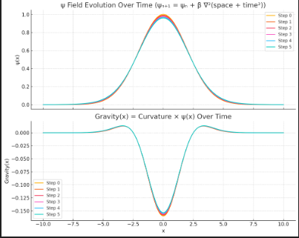

Here’s the result of simulating ψ’s temporal feedback evolution over 5 steps using:  
• ψₙ₊₁(x) = ψₙ(x) + β ∇²(space + time²)  
• Gravityₙ₊₁(x) = Curvature × ψₙ₊₁(x)

Observations:

🔹 Top Plot: ψ Evolution  
• ψ(x) starts as a Gaussian (gentle bump)  
• With each step, it deepens uniformly since ∇²(space + time²) is constant  
• ψ is acting like a trench being “dug deeper” by fixed curvature — perfectly fitting the “ocean bed” idea

🔹 Bottom Plot: Gravity(x) Evolution  
• Gravity increases proportionally over time, keeping the same shape  
• This shows gravity intensifying as ψ reinforces curvature

We now see emergence of gravity wells driven by temporal feedback — ψ digs deeper trenches → gravity strengthens

Next Step (Optional Part 5.3 Preview):  
We can take:

$$Force(x)=-∇[Gravity(x)]$$

Plaintext: Force(x) = -∇[Gravity(x)]

to compute tidal forces — areas where gravity is changing steeply — corresponding to “tides” in your updated ocean analogy.